NOV 2023

REPORT ANALYSIS

YOUTUBE STREAMERS DATA ANALYIS

**BY**

**Olayinka amusah**

# **INTRODUCTION**

This is an internship task given by Intern Career to gain hands-on experience, analyze data using real world dataset. The dataset is called YouTube Streamer Analysis. This dataset contains valuable information about top YouTube streamers, their ranking, categories, subscribers, country, visits, likes, comments and links.

The dataset is a top 1000 YouTubers statistics and the task to perform is to analyze and extract insights about the top YouTube content creators following guidelines for Data exploration, Trend Analysis, Audience Study, Performance Metrics, Content Categories, Brands and Collaborations, Benchmarking and Content Recommendations.

Data analytics tool will be used to analyze the data in order to gain insights and make data driven decisions and recommendation, in form of tables and visualizations with a detailed report.

TABLE OF CONTENT

INTRODUCTION 1

TABLE OF CONTENT 2

YOUTUBE STREAMERS ANALYSIS 3-4

ANALYSIS (TREND ANALYSIS) 5

FINDINGS 1 5-6

FINDINGS 2 7

FINDINGS 3 8

AUDIENCE STUDY 9-10

PERFOMANCE METRICS 11

CONTENT CATEGORIES 12-13

BRANDS AND COLLABORATION 13

BENCHMARKING 14-16

RECOMMENDATION 17

APPENDIX 18

# **YOUTUBE STREAMERS ANALYSIS**

The dataset is on a CSV file which was loaded to Power Bi for further analysis. The YouTube Streamers dataset has 1000 rows and 9 columns with key variables which are:

**Data Metrics:**

Rank: Numeric values

User name: Names of the Youtubers

Categories: Different specializations

Subscribers: Number of followers/audiences

Country: Youtuber’s country

Visits: Number of viewers/streamers

Likes: Number of likes

Comment: Number of comments

Links: Content address

**Data Design:**

The YouTube Streamers dataset is cleaned in Power Query.

1. The header column name Visit was in Decimal and was changed to whole number.
2. The Categories column had 305 missing values which will be removed.
3. Removed duplicate in the Link column and was left with 689 rows
4. While working on the data in the Country column there were some rows that had unknown countries which was replaced with a blank row then removed. The dataset is now left with 555 rows.

We now have 555 Usernames, 40 distinct Categories, 196 distinct Subscribers,26 distinct Countries, 422 distinct Visits, 406 distinct Likes, 306 distinct Comments and 555 distinct Links which will be used in the analysis of the YouTube Streamers trend analysis.

# **ANALYSIS**

## **TREND ANALYSIS**

These are the questions that will be used to analyze the trend in the YouTube Streamers dataset.

1. What is the trends among top youtubers?
2. Which categories are the most popular?
3. Is there a correlation between the number of subscribers and the number of likes or comment

### Findings 1:

What is the trend among top youtubers?

Table 1:

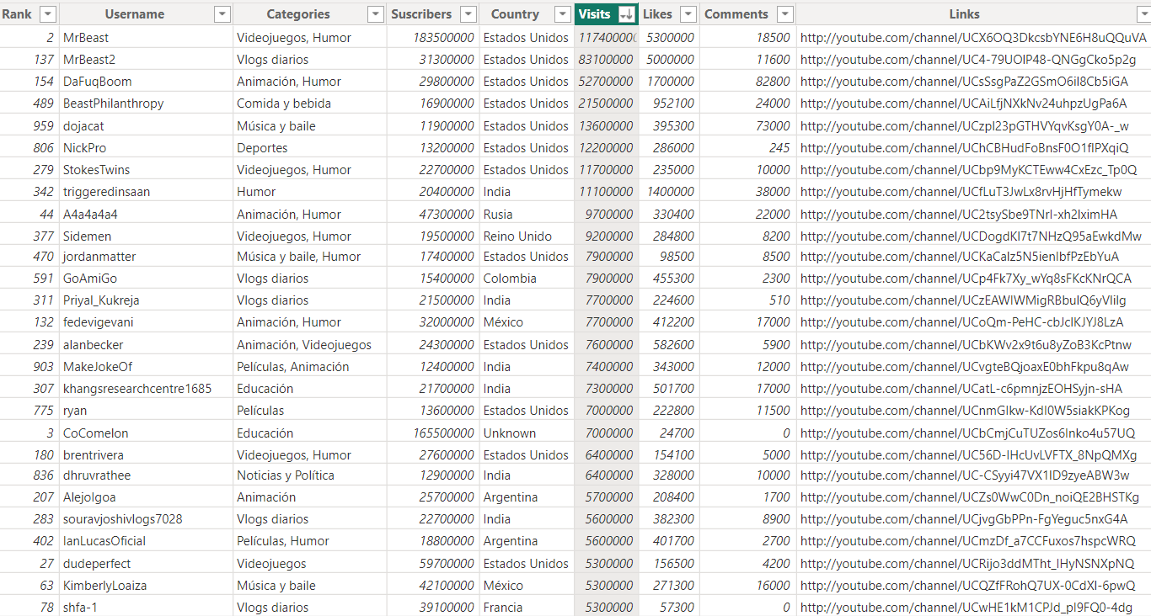

To analyze the trend among top youtubers we look at the variables Username, Subscribers, Visits and Categories. The average number of Visits and subscribers make up the streamers and from the table we filter from the Visits column to get the top Usernames, Categories and Subscribers. It also shows that Ranking does not determine the top Youtubers from the dataset.

Top 10 youtubers we have is:

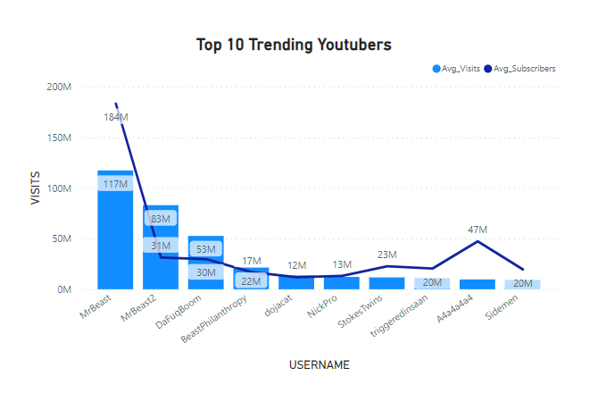MrBeast

MrBeast2

DaFuqBoom

BeastPhilanthrophy

dojacat

Nickpro

StokeTwins

triggeredinsaan

A4a4a4a4a4

Sidemen Fig 1

Looking at Country in the table, we see that Estado Unidos, India, Russia and Rein Unido are the countries where the top Youtubers who are most trending come from and they are all in different categories with Estado Unidos with the highest number of Visits in 7 categories.

### Findings2:

Which categories are the most popular?

The most popular categories can be gotten from the number of streamers that visits the youtubers channel. Which is shown in a section of the table below that Videojuegos Humor, Vlogs diarios, Animacion Humor are the top 3 categories. With Videojuegos Humor having the highest number of Visits.

Table 2:

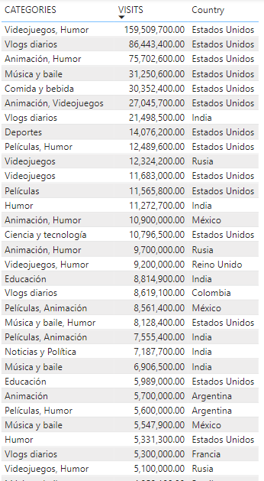

### Findings 3:

Is there a correlation between the number of subscribers and the number of likes or comment.

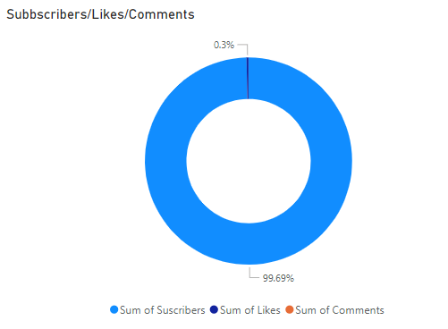There might be a correlation between the number of subscribers and the number of likes or comments, though it doesn’t mean one variable causes the changes of another. There are billions of subscribers which is at 99.69 %, the number of likes is 0.3% and the number of comments is 0.01% which is close to zero.

Fig 2:

NB:

* The relationship between subscribers and likes is very weak though there is a tendency that as the number of subscribers increase the number of likes will also increase.
* The relationship between the number of subscribers and comments is extremely weak.
* There is an almost negligible relationship between number of Likes and Comments since the percentage of Likes is close to Comments.

## **Audience Study**

To analyze the audience, we will study the distribution of streamers by country.

Table 3:

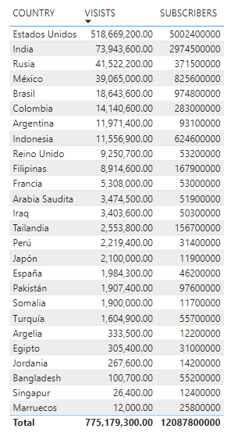

* Audience represents the Subscribers.
* Streamers represent Visits.

The distribution of streamers audience by country in the table above shows that Estados Unidos has the highest number of Visits followed by India, Rusia, Mexico and Brasil.

Singapore and Marruecos has the lowest distribution of streamers by audience.

Are there regional preference for specific content categories?

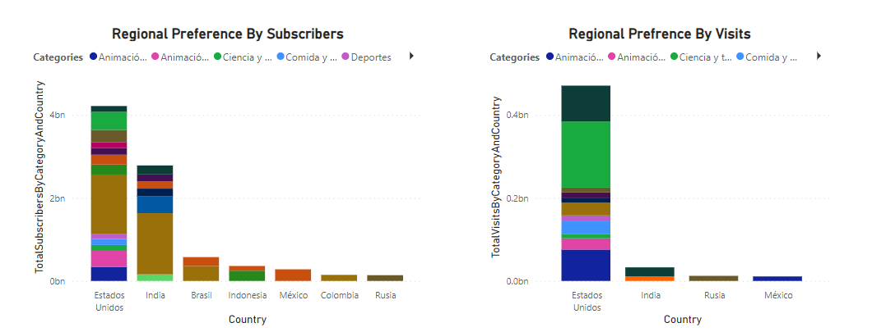

Fig 3

The chart above shows two different preferences between the total subscribers and the total number of visits by the country.

* The chart to the left is represented by different colors and the color brown seems to be the one that has more specific content categories which is Musica y baile from the total number of subscribers
* The chart to the right is represented by different colors and the color green seem to be the one that has more specific content categories which is Videojuegos Humor from the total number of visits.

NB:

The YouTube Streamers dataset does not specify the regions of the audience or streamers, so the number of subscribers and visits was used to analyze the content categories preference by country.

**Performance Metrics**

The performance metrics for Average number of Subscribers, Visits, Likes and Comments are

* 21.78M Average Subscribers
* 1.40M Average Visits
* 66.03K Average Likes
* 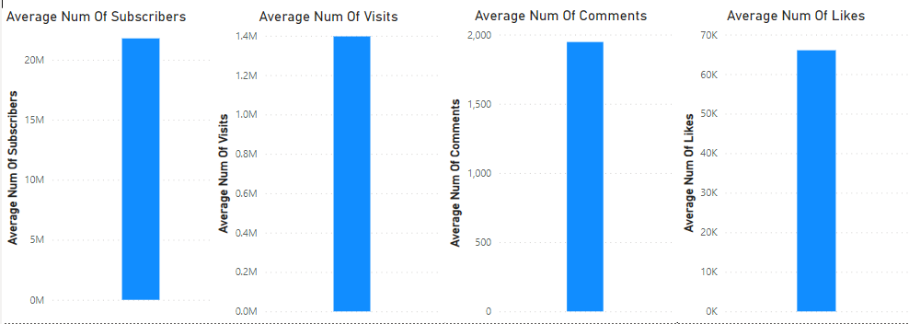1.95k Average Comments

Fig 4

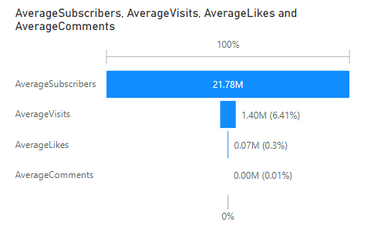Analyzing the patterns and anomalies:

Fig 5

The pattern or anomalies metrics in the chart above shows that the average number of subscribers is more than the other variables.

**Content Categories**

This is to explore the distribution of content categories in the YouTube Streamers dataset.

1. Which categories have the highest number of streamers?

To analyze the highest number of streamers, we will look at the top 20 of the categories in the table below:

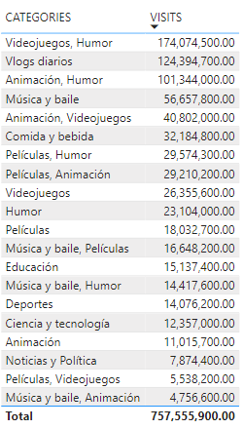TABLE 4:

1. Are there specific categories with exceptional performance metrics?

There are three top categories with exceptional performance metrics of streamers on the chart.

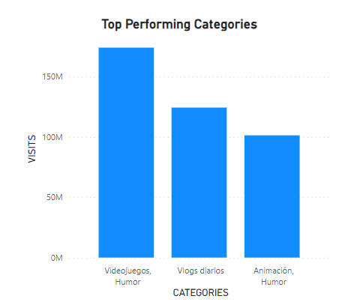FIG6

* Videojuegos with 174M Visits
* Vlogs diarios with 126.3M Visits
* Animacion Humor 101.5M Visits

**Brands and Collaborations:**

Analyze whether streamers with high performance metrics receive more brand collaborations and marketing campaigns.

Findings:

From the YouTube Streamers dataset there are no variables that can be used to analyze streamers with high performance metrics to receive brand collaborations and marketing campaigns.

**Benchmarking**

1. Identify streamers with above-average performance in terms of subscribers, visits, likes and comments.

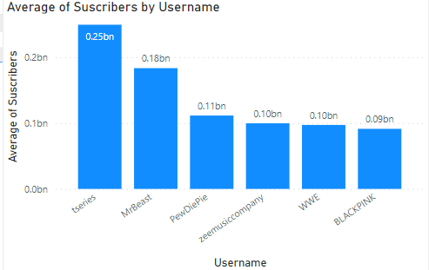In order to identify the above average performance, the key variable that will be used is the Username since some of the analysis done so far in this report has been on the Categories and Countries data of the YouTube Streamers.

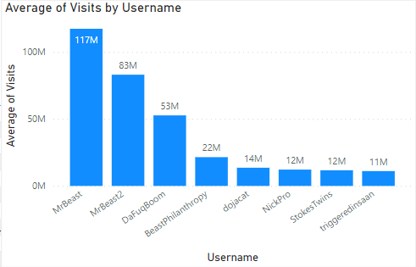Fig 7

Fig 8

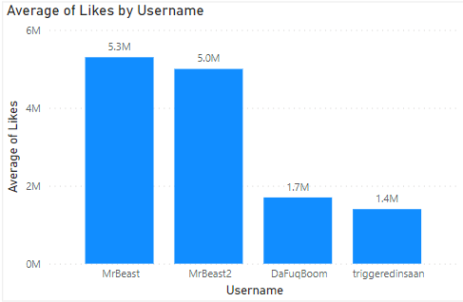

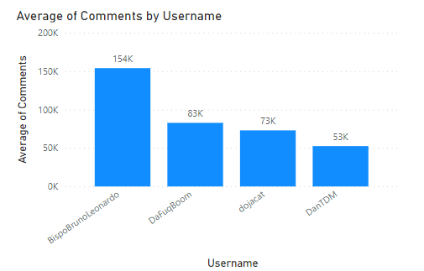Fig 9

Fig 10

* In terms of Subscribers, tseries has an average of 249.5B
* In terms of Visits, MrBeast has an average of 117.4M
* In terms of Likes, MrBeast has an average of 5.3M
* In terms of Comment, BispoBrunoLeonardo has an average of 154k

1. Who are the top-performing content creators

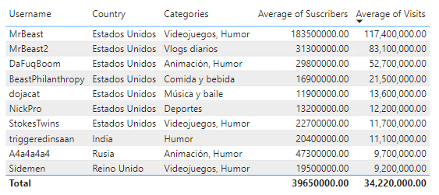Table 5:

* The 10 top-performing content creators using their average number of Visits are:

MrBeast

MrBeast2

DaFuqBoom

BeastPhilanthrophy

dojacat

Nickpro

StokeTwins

triggeredinsaan

A4a4a4a4a4

Sidemen

## **RECOMMENDATION**

The analysis of the YouTube Streamer show a lot of trends that could help improve the overall metrics of both high and low performing content creators.

These are some recommendations to implement.

* Content creators should consider exploring the popular categories.
* They should consider collaborative events between creators in these high performing categories.
* They should tailor their content to the preference of the audience like countries with high performing categories.
* Collaborate with top content creators from these countries to expand their audience base.
* Creators should consistently focus on increasing their engagement metrics i.e. Likes & Comments in relative to the subscribers.
* Creators should encourage the audience streamers to Like, Comment and Subscribe to increase the Visit to Subscriber ratio.
* Content creators with high performing metrics should explore brand collaboration or marketing campaigns.

## **APPENDIX**

**Dataset provided by Intern Career**

The YouTube Streamers Data

**Tools Used for Analysis and Report**

Microsoft Power bi & Microsoft Word

**Visualizations and Tables**

Microsoft Power Bi